What you know - Wavelength Worksheet

- Label Wavelength, Period (T), Amplitude

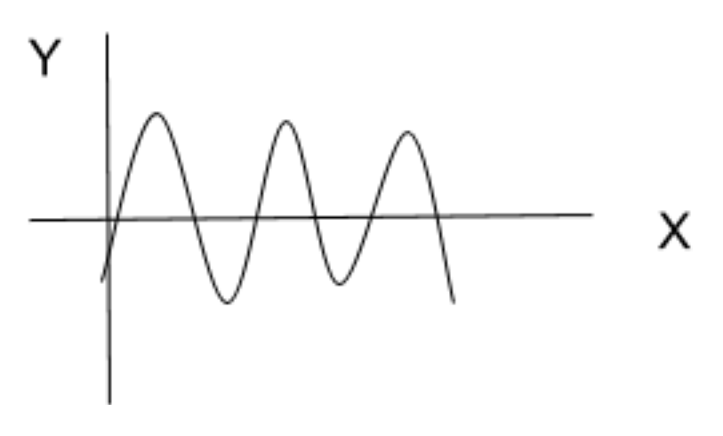

2) If frequency increases wavelength gets longer. True or False

ANSWER: FALSE

3) If fre quency decreases wavelength gets shorter. True or False

ANSWER: FALSE

4) Examples of electromagnetic waves used in our daily lives mentioned in the video.
ANSWER: RADIO WAVES, SATELLITE WAVES, CELL PHONES, ETC
5) What is an oscillation?
- Up and down movement
- Side to side movement
- Movement back and forth at a regular speed

