What You Know Worksheet

Label the following diagram.
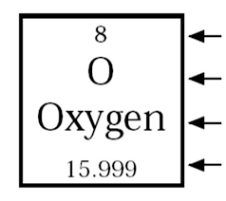
Atomic number: 8
Chemical symbol: O
Element name: oxygen
Mass number: 15.999

Fill in the blank.

- How many protons does oxygen have:

8

2. How many electrons does oxygen have:
8

3. How many neutrons does oxygen have:
Atomic mass-proton=neutrons
16-8=8

4. What subatomic particles do atoms consist of:

Protons, neutrons and electrons

Note to substitute: please go over answer key after quiz.

