Practice for Trimester Test

Science definitions
- What is science?
Knowledge about the world and system for answering new questions about what we already know.
- Tell me the difference between an opinion and a fact?
Opinion: A statement of a personal belief, for example, good/bad, think, guess, interpretation, or point of view.
Fact: A statement everyone can agree is true, for example, based on numbers, statistics, verified (more than one person can confirm), recorded, proven, or eyewitness.
- What is an observation?
Things that we either can see visually (ex. Picture or in action) or figuratively (ex. Paragraph or story).

- What is an inference?
The process of drawing conclusions based on logic or previous observations.
- What is a scientific method? (Don’t list the 5 steps)
A set of procedures that scientists/researchers use to help explain why something occurs or takes place.

- What is a hypothesis?
An estimated guess or testable explanation for the details you observe.
- What is a question?
What you want to learn?
- What is a experiment?
What you’ll do to test your hypothesis and answer your question.

- What is data/analysis?
The information you gathered during the experimentation section of a scientific experiment.
- What is a theory?
A statement that explains something after it has been repeatedly confirmed through experimental testing.

Atoms and Periodic Table
- What is an atom? Subunits?
An atom is the smallest unit of matter. The subunits are: protons, neutrons and electrons.
- What is atomic weight?
The number of protons and neutrons

- If you know the number of protons can you determine the number of electrons?
Yes, the number of protons equals to the number of electrons.
- How do you determine the number of neutrons in an atom?
Atomic mass = number of protons + number of neutrons

After rearranging the formula you have,
Number or neutrons = atomic mass – number of protons

- What charges do subunits have (protons, neutrons, and electrons)?
Protons (+)
Neutrons (no charge)
Electrons (--)
- Mendeleev arranged the elements in his periodic table in order of __Atomic mass_
- Medeleev’s decision to leave a gaps in his periodic table was supported by the discovery of _Gallium_.
- In modern periodic table, elements are arranged in order of _Atomic number_.
- a. How many periods does the periodic table have?
7 periods
b. Are chemical properties similar?
No, chemical properties are not all similar.

c. Do elements have same number of valence shells?
No, elements don’t have the same number of valence electrons or electrons increases as the atomic number increases.
- a. How many group does the periodic table have?
18 groups
b. Are chemical properties similar?
Yes, chemical properties are the similar.
c. Do elements have same number of valence shells?
No, elements in different groups don’t have same number of valence electrons or electrons.

Yes, elements in same groups do have same number of valence electrons or electrons.

- An element that is shiny and conducts electric current is likely to be a _metal_.
- Copper is an example of a _transitional_ metal.
- Elements that have the same number of valence electrons are _in the same group_.
- The most reactive metals are the _Alkali metals_.
- Which elements group are all gases at room temperature?
Group 8

- What information did Mendeleev have about the elements he organized into a period table?
Atomic weight

- How did Mendeleev know where to leave the spaces in his table?
Mendeleev placed elements in the groups where they logically belonged based on their properties.
- Why is the table of elements vary from period to period?
The number of valence electrons increases as the atomic number increases.

- Elements can be classified by whether they are (clue, three states):
Solid, liquid, or gas
- What happens to the reactivity of elements as atomic numbers increase across a period?
Across a period from left to right, metals become less reactive and nonmetals become more reactive, excluding the elements in Group 8A.

- Which element is called quicksilver and is a liquid metal?
Mercury

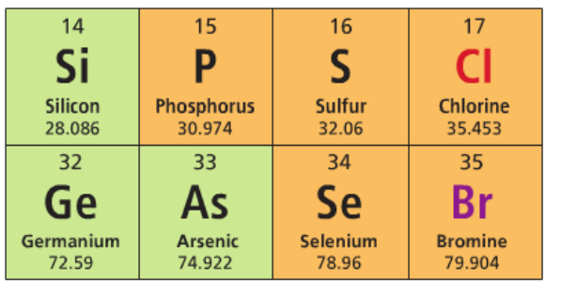

Use this picture for the questions 22 – 23. (Note I made a mistake here with the number of questions.)

- How many of the elements shown above are metals? Nonmetals? Metalloids?
0 metals, 5 nonmetals, and 3 metalloids
- Which halogen shown above is more reactive? (Note Fluorine is the most electronegative element on the periodic table). NOTE: So electronegativity increases from left to right and from bottom up.
Chlorine as is the most electronegative in the example.
- How many valence electrons would an element with 35 have?
35 valence electrons
- Why are halogens found in nature only in compounds or bonded to other elements?
Halogens are very reactive

- Which elements on the periodic table give out more than one set of valence electrons? Note: they are loosely goosey.
Transitional metals
- Which group on the period table are stable?
Noble gases

- How are metalloid different from metal and non-metals?
Metalloids are neither metals or non-metals. They show similar properties to both groups. For example, they appear as metals as they are shiny but are poor conductors of electricity and heat.

