Quiz# 7
- Name ONE EXAMPLE what scientist do?
EXAMPLES: COLLECT, STUDY, ANALYZE, ANSWER QUESTIONS AND SOLVE PROBLEMS
- Match the tool to its functions:

- THERMOMETER Volume

- SCALE OR BALANCE Temperature

- RULER Length

- GRADUATED CYLINDER Weight or Mass

- Define the two type of data:

- QUALITATIVE: DATA DOESN’T USE NUMBERS

- QUANTITATIVE: DATA USES NUMBERS

- Give me a description of the following picture:

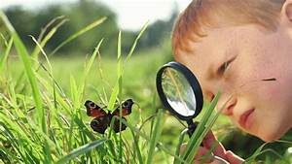

The boy is observing a butterfly with a magnifying glass.

- Match the five scientific Methods with the definitions
- Question What happened during the experiment? Discuss
your findings and answer your question.

- Hypothesis Test your questions by doing an experiment

- Experiment Record information needed to answer your
question, and to disapprove or approve your
hypothesis.

- Analysis/Data What do you want to learn?

- Conclusion Take a guess on what you think the answer to
your question might be.

